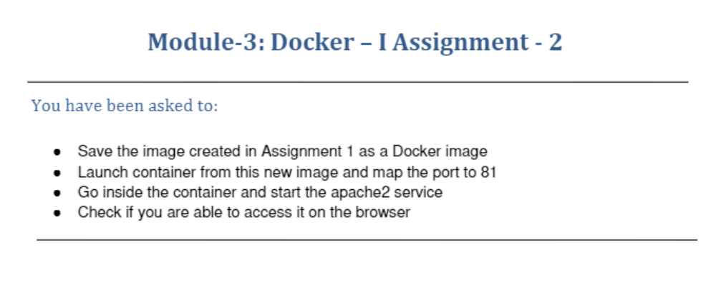
ubuntu@ip-172-31-39-74:~$ sudo docker images
REPOSITORY TAG IMAGE ID CREATED SIZE
veerannagatate/apachenew latest 3a61383fa440 18 minutes ago 217MB
ubuntu latest 597ce1600cf4 12 days ago 72.8MB
ubuntu@ip-172-31-39-74:~$ sudo docker ps
CONTAINER ID IMAGE COMMAND CREATED STATUS PORTS NAMES
d7ec113fba78 veerannagatate/apachenew "bash" 17 minutes ago Up 17 minutes 0.0.0.0:82->80/tcp, :::82->80/tcp busy_panini
6a4dc82797a9 ubuntu:latest "bash" 48 minutes ago Up 26 minutes vibrant_einstein
ubuntu@ip-172-31-39-74:~$ sudo docker exec -it d7ec113fba78 bash
root@d7ec113fba78:/# service apache2 status
* apache2 is running
root@d7ec113fba78:/# exit
exit
ubuntu@ip-172-31-39-74:~$ sudo docker run -it -p 82:81 -d veerannagatate/apachenew
52834bf528eead3a5c7027245e40ae876360631b1d2e509b17cc75867fed20a4
docker: Error response from daemon: driver failed programming external connectivity on endpoint competent_knuth (1cc71cd08409f2676b2767ef785e7df67facd372a7b211b2529d9af6cf1e43c7): Bind for 0.0.0.0:82 failed: port is already allocated.
ubuntu@ip-172-31-39-74:~$ sudo docker run -it -p 80:81 -d veerannagatate/apachenew
a407e4155ff0e5c9d0e3592ff505e4a2d754b1fc93b7ba4a1d77ae06028294ee
ubuntu@ip-172-31-39-74:~$ sudo docker exec -it d7ec113fba78 bash
root@d7ec113fba78:/# service apache2 status
* apache2 is running
root@d7ec113fba78:/# exit
exit
ubuntu@ip-172-31-39-74:~$ sudo docker run -it -p 80:81 -d veerannagatate/apachenew
f385351ce51e26291db479b9841728be3cd2bbc6516cb6577740eb1aee682b1d
